**Answer to the Question Number: 01**

#include<stdio.h>

int main()

{

FILE *cfptr;

char fname[20];

printf(" Input the filename to be opened : ");

scanf("%s",fname);

cfptr = fopen(fname, "w");

if(cfptr==NULL)

{

printf(" File does not exist or can not be opened.");

}

else

{

int num;

printf("Enter your numbers : ");

scanf("%d" , &num);

while(num!=-1)

{

fprintf(cfptr, "%d " , num);

scanf("%d", &num);

}

fclose(cfptr);

}

cfptr = fopen(fname, "r");

if(cfptr==NULL)

{

printf(" File does not exist or can not be opened.");

}

else

{

int num;

fscanf(cfptr, "%d" , &num);

while(!feof(cfptr))

{

printf("%d " , num);

fscanf(cfptr, "%d" , &num);

}

fclose(cfptr);

}

return 0;

}

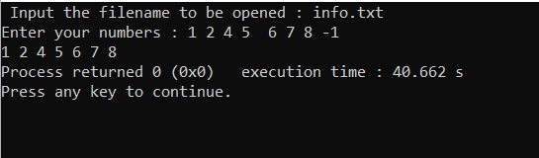

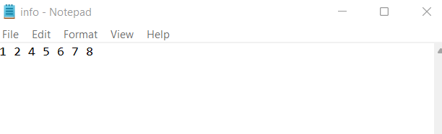

**Answer to the Question Number: 02**

#include<stdio.h>

int main()

{

FILE *cfptr;

char fname[20];

printf(" Input the filename to be opened : ");

scanf("%s",fname);

cfptr = fopen(fname, "w");

if(cfptr==NULL)

{

printf(" File does not exist.");

}

else

{

int num;

printf("Enter your numbers : \n");

scanf("%d" , &num);

while(num!=-1)

{

fprintf(cfptr, "%d " , num);

scanf("%d", &num);

}

fclose(cfptr);

}

cfptr = fopen(fname, "r");

if(cfptr==NULL)

{

printf(" File does not exist or can not be opened.");

}

else

{

int num, sum=0;

fscanf(cfptr, "%d" , &num);

while(!feof(cfptr))

{

printf("%d " , num);

sum+=num;

fscanf(cfptr, "%d" , &num);

}

printf("\nSum=%d",sum);

fclose(cfptr);

}

return 0;

}

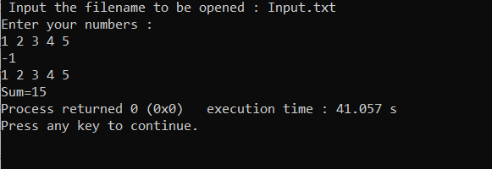

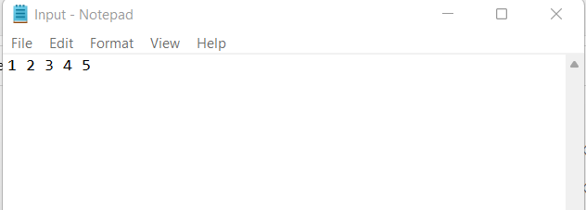

**Answer to the Question Number: 03**

#include<stdio.h>

#include<string.h>

int main()

{

FILE *flab;

char name[20];

printf("enter your text here: ");

gets(name);

int length=strlen(name);

int i;

flab=fopen("ToDoLIst.txt","a");

if(flab==NULL)

printf("file opened");

else

printf("opened");

for(i=0;i<length;i++)

{

fputc(name[i],flab);

}

printf("\n file is up ");

fclose(flab);

}

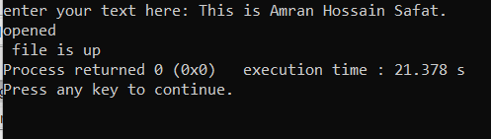

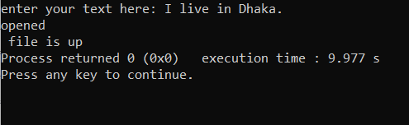

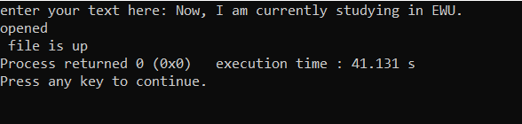

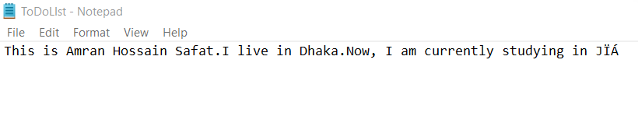

**Answer to the Question Number: 04**

#include<stdio.h>

struct car

{

char name[20];

char model[20];

int year;

double price;

};

int main()

{

char f_name[50];

FILE *af;

printf("Enter file name: ");

scanf("%s", f_name);

af = fopen(f_name, "w");

printf("\t\t\t\t\tHow many inputs you want to add : ");

int n;

scanf("%d", &n);

struct car arr[n];

for(int i = 0; i < n; i++){

printf("\nEnter car Name: ");

scanf("%s", arr[i].name);

printf("\nEnter model : ");

scanf("%s", arr[i].model);

printf("\nEnter year : ");

scanf("%d", &arr[i].year);

printf("\nEnter car Price: ");

scanf("%lf", &arr[i].price);

fprintf(af, "%s %s %d %.2f\n", arr[i].name, arr[i].model, arr[i].year, arr[i].price);

}

fclose(af);

FILE *rf;

rf = fopen(f_name, "r");

if(rf == NULL){

printf("Error Opening File\n");

exit(1);

}else{

system("cls");

char name[20];

char model[20];

int year;

double price;

printf("\n\t\t\t\t\t Current cars in Showroom\n");

printf("\t\t\t\t\t=====================================\n");

printf("\t\t\t\t\tID Name\t\tMode\t\tYear\t\tPrice\n");

printf("\t\t\t\t\t=====================================\n");

while(fscanf(rf, "%s %s %d %lf", name, model, &year, &price) != EOF){

printf("\t\t\t\t\t%s. %s\t %d\t\t%.2lf\n", name, model, year, price);

}

fclose(rf);

}

}

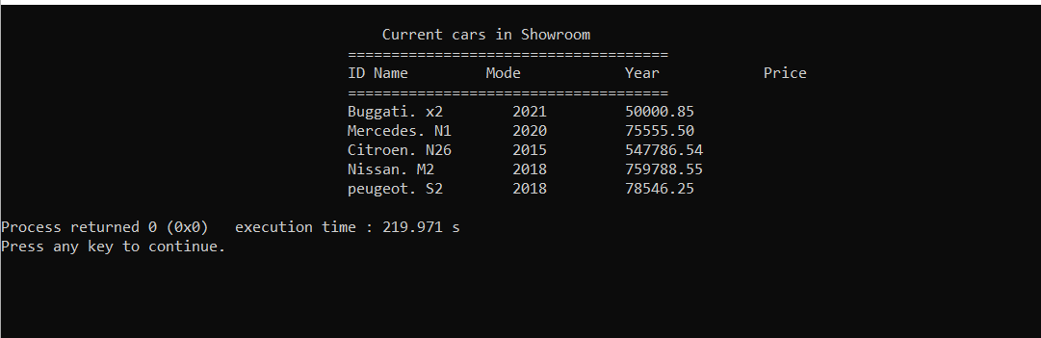

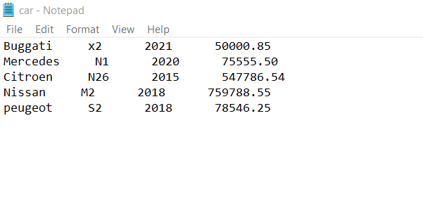

**Answer to the Question Number: 05**

#include<stdio.h>

#include<stdlib.h>

struct Box{

int length;

int width;

int height;

};

struct Box boxSum(struct Box box1, struct Box box2){

struct Box newBox;

newBox.length = box1.length + box2.length;

newBox.width = box1.width + box2.width;

newBox.height = box1.height + box2.height;

return newBox;

}

int main()

{

struct Box box1, box2, newBox;

box1.length = 10;

box1.width = 5;

box1.height = 3;

box2.length = 5;

box2.width = 3;

box2.height = 1;

newBox = boxSum(box1, box2);

printf("Box 1 length = %d\n", box1.length);

printf("Box 1 width = %d\n", box1.width);

printf("Box 1 height = %d\n\n", box1.height);

printf("Box 2 length = %d\n", box2.length);

printf("Box 2 width = %d\n", box2.width);

printf("Box 2 height = %d\n\n", box2.height);

printf("New box length = %d\n", newBox.length);

printf("New box width = %d\n", newBox.width);

printf("New box height = %d\n", newBox.height);

return 0;

}

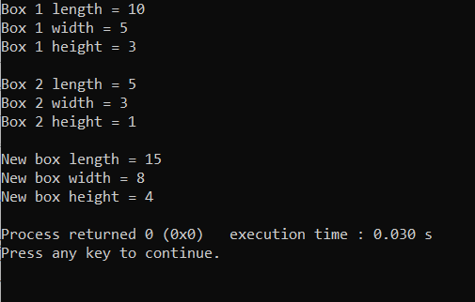

**Answer to the Question Number: 06**

#include<stdio.h>

#include<stdlib.h>

int main(){

system("cls");

FILE *f;

f = fopen("sort_file.txt","w");

if(f == NULL){

printf("Error opening file\n");

exit(1);

}else{

int n, size=0;

printf("Enter a number: ");

scanf("%d",&n);

while(n != -1){

fprintf(f,"%d\n",n);

printf("Enter a number: ");

scanf("%d",&n);

size++;

}

fclose(f);

int arr[size];

FILE *f2;

f2 = fopen("sort_file.txt","r");

if(f2 == NULL){

printf("Error opening file\n");

exit(1);

}else{

int n2, i=0;

while(fscanf(f2,"%d",&n2) != EOF){

printf("%d\n",n2);

arr[i] = n2;

i++;

}

fclose(f2);

}

for(int i=0; i<size; i++){

for(int j=0; j<size-1; j++){

if(arr[j] > arr[j+1]){

int temp = arr[j];

arr[j] = arr[j+1];

arr[j+1] = temp;

}

}

}

printf("\nSorted array: ");

for(int i=0; i<size; i++){

printf("%d ",arr[i]);

}

}

return 0;

}

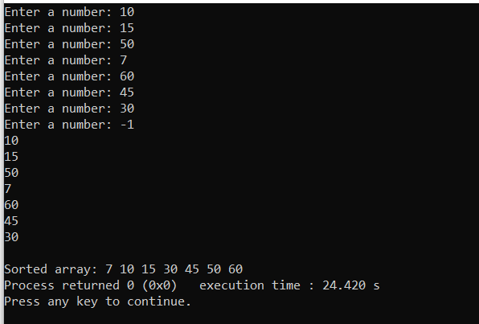

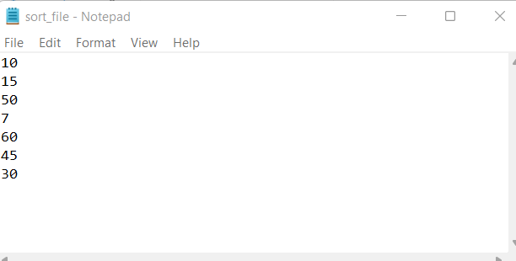

**Answer to the Question Number: 07**

#include <stdio.h>

#include <stdlib.h>

void main()

{

FILE *fptr;

char ch;

int wrd=1,charctr=1;

char fname[20];

printf("\n\n Count the number of words and characters in a file :\n");

printf("---------------------------------------------------------\n");

printf(" Input the filename to be opened : ");

scanf("%s",fname);

fptr=fopen(fname,"r");

if(fptr==NULL)

{

printf(" File does not exist or can not be opened.");

}

else

{

ch=fgetc(fptr);

printf(" The content of the file %s are : ",fname);

while(ch!=EOF)

{

printf("%c",ch);

if(ch==' '||ch=='\n')

{

wrd++;

}

else

{

charctr++;

}

ch=fgetc(fptr);

}

printf("\n The number of words in the file %s are : %d\n",fname,wrd);

printf(" The number of characters in the file %s are : %d\n\n",fname,charctr-1);

}

fclose(fptr);

}

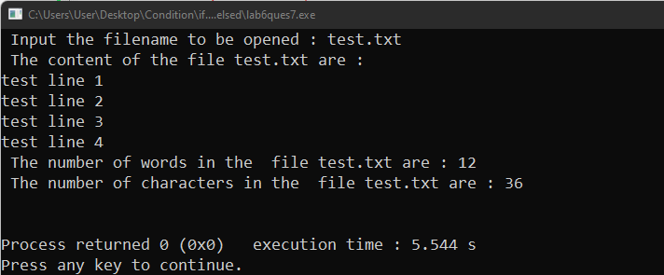

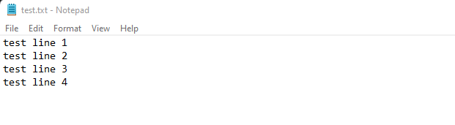

**Answer to the Question Number: 08**

#include<stdio.h>

#include<stdlib.h>

#include<string.h>

struct Student{

int roll;

char name[50];

};

int main()

{

struct Student students[2];

students[0].roll = 100918273;

strcpy(students[0].name, "Alan Jones");

students[1].roll = 239495959;

strcpy(students[1].name, "James Bond");

FILE *fptr = fopen("students.txt", "w");

for(int i = 0; i < 2; i++){

fprintf(fptr, "roll_no = %d ", students[i].roll);

fprintf(fptr, "name = %s\n", students[i].name);

}

fclose(fptr);

fptr = fopen("students.txt", "r");

char c = fgetc(fptr);

while (c != EOF)

{

printf ("%c", c);

c = fgetc(fptr);

}

fclose(fptr);

return 0;

}

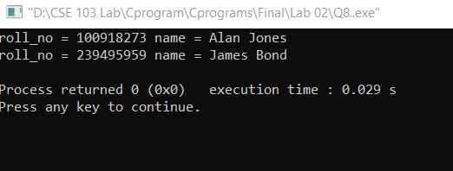

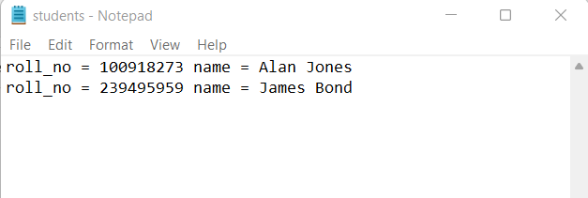

**Answer to the Question Number: 09**

#include <stdio.h>

#include <stdlib.h>

void menu();

struct Product{

int id;

char name[20];

int quantity;

double price;

};

void Create(){

system("cls");

char f_name[50];

printf("Enter file name: ");

scanf("%s", f_name);

FILE *cf;

cf = fopen(f_name, "w");

if(cf == NULL){

printf("Error Opening File\n");

exit(1);

}else{

system("cls");

printf("How Many Products You Want To Store In Your Shop: ");

int n;

scanf("%d", &n);

struct Product arr[n];

for(int i = 0; i < n; i++){

system("cls");

printf("You are entering %d th product information\n", i+1);

arr[i].id = i+1;

printf("\nEnter Product Name: ");

scanf("%s", arr[i].name);

printf("\nEnter Product Quantity: ");

scanf("%d", &arr[i].quantity);

printf("\nEnter Product Price: ");

scanf("%lf", &arr[i].price);

fprintf(cf, "%d %s %d %.2f\n", arr[i].id, arr[i].name, arr[i].quantity, arr[i].price);

}

fclose(cf);

FILE *rf;

rf = fopen(f_name, "r");

if(rf == NULL){

printf("Error Opening File\n");

exit(1);

}else{

system("cls");

printf("\n\t\t\t\t\t Current Product in Your Shop\n");

printf("\t\t\t\t\t=====================================\n");

printf("\t\t\t\t\tID Name\t\tQuantity\tPrice\n");

printf("\t\t\t\t\t=====================================\n");

for(int i=0; i<n; i++){

while(fscanf(rf, "%d %s %d %lf", &arr[i].id, arr[i].name, &arr[i].quantity, &arr[i].price) != EOF){

printf("\t\t\t\t\t%d. %s\t %d\t\t%.2lf\n", arr[i].id, arr[i].name, arr[i].quantity, arr[i].price);

}

}

printf("\t\t\t\t\t=====================================\n");

fclose(rf);

}

}

int choice;

printf("\n\t\t\t\t\tIf you want to go main menu press 1\n\t\t\t\t\tIf you want to exit press 2.\n");

printf("\t\t\t\t\tYour Choice:: ");

scanf("%d", &choice);

if(choice == 1){

menu();

}else{

exit(0);

}

}

void Add(){

system("cls");

char f_name[50];

printf("Enter file name: ");

scanf("%s", f_name);

FILE *cf;

cf = fopen(f_name, "r");

if(cf == NULL){

printf("Error Opening File\n");

exit(1);

}else{

system("cls");

int id;

char name[20];

int quantity;

double price;

printf("\n\t\t\t\t\t Current Product in Your Shop\n");

printf("\t\t\t\t\t=====================================\n");

printf("\t\t\t\t\tID Name\t\tQuantity\tPrice\n");

printf("\t\t\t\t\t=====================================\n");

while(fscanf(cf, "%d %s %d %lf", &id, name, &quantity, &price) != EOF){

printf("\t\t\t\t\t%d. %s\t %d\t\t%.2lf\n", id, name, quantity, price);

}

printf("\t\t\t\t\t=====================================\n");

fclose(cf);

FILE *af;

af = fopen(f_name, "a");

printf("\t\t\t\t\tHow many products you want to add in your shop: ");

int n;

scanf("%d", &n);

struct Product arr[n];

for(int i = 0; i < n; i++){

system("clear");

printf("You are entering %d th product information\n", id+1);

arr[i].id = id+1;

printf("\nEnter Product Name: ");

scanf("%s", arr[i].name);

printf("\nEnter Product Quantity: ");

scanf("%d", &arr[i].quantity);

printf("\nEnter Product Price: ");

scanf("%lf", &arr[i].price);

fprintf(af, "%d %s %d %.2f\n", arr[i].id, arr[i].name, arr[i].quantity, arr[i].price);

}

fclose(af);

}

int choice;

printf("\n\t\t\t\t\tIf you want to go main menu press 1\n\t\t\t\t\tIf you want to exit press 2.\n");

printf("\t\t\t\t\tYour Choice:: ");

scanf("%d", &choice);

if(choice == 1){

menu();

}else{

exit(0);

}

}

void Read(){

system("cls");

char f_name[50];

printf("Enter file name: ");

scanf("%s", f_name);

FILE *rf;

rf = fopen(f_name, "r");

if(rf == NULL){

printf("Error Opening File\n");

exit(1);

}else{

system("cls");

int id;

char name[20];

int quantity;

double price;

printf("\n\t\t\t\t\t Current Product in Your Shop\n");

printf("\t\t\t\t\t=====================================\n");

printf("\t\t\t\t\tID Name\t\tQuantity\tPrice\n");

printf("\t\t\t\t\t=====================================\n");

while(fscanf(rf, "%d %s %d %lf", &id, name, &quantity, &price) != EOF){

printf("\t\t\t\t\t%d. %s\t %d\t\t%.2lf\n", id, name, quantity, price);

}

printf("\t\t\t\t\t=====================================\n");

fclose(rf);

}

int choice;

printf("\n\t\t\t\t\tIf you want to go main menu press 1\n\t\t\t\t\tIf you want to exit press 2.\n");

printf("\t\t\t\t\tYour Choice:: ");

scanf("%d", &choice);

if(choice == 1){

menu();

}else{

exit(0);

}

}

void Update(){

system("cls");

char f_name[50];

printf("Enter file name: ");

scanf("%s", f_name);

FILE *ef;

ef = fopen(f_name, "r");

if(ef == NULL){

printf("Error Opening File\n");

exit(1);

}else{

system("cls");

int id;

char name[20];

int quantity;

double price;

printf("\n\t\t\t\t\t Current Product in Your Shop\n");

printf("\t\t\t\t\t=====================================\n");

printf("\t\t\t\t\tID Name\t\tQuantity\tPrice\n");

printf("\t\t\t\t\t=====================================\n");

while(fscanf(ef, "%d %s %d %lf", &id, name, &quantity, &price) != EOF){

printf("\t\t\t\t\t%d. %s\t %d\t\t%.2lf\n", id, name, quantity, price);

}

printf("\t\t\t\t\t=====================================\n");

}

rewind(ef);

printf("\n\n\t\t\t\t\tEnter Product ID You Want To Edit: ");

char target;

scanf("%d", target);

remove(f_name);

FILE *wf;

wf = fopen(f_name, "w");

if(wf == NULL){

printf("Error Opening File\n");

exit(1);

}else{

system("cls");

int id;

char name[20];

int quantity;

double price;

while(fscanf(ef, "%d %s %d %lf", &id, name, &quantity, &price) != EOF){

if(id == target){

printf("\n\t\t\t\t\t You Are Updating This Product\n");

printf("\t\t\t\t\t=====================================\n");

printf("\t\t\t\t\tID Name\t\tQuantity\tPrice\n");

printf("\t\t\t\t\t=====================================\n");

printf("\t\t\t\t\t%d. %s\t %d\t\t%.2lf\n", id, name, quantity, price);

printf("\n\n\t\t\t\t\tEnter New Product Name: ");

scanf("%s", name);

printf("\n\n\t\t\t\t\tEnter New Product Quantity: ");

scanf("%d", &quantity);

printf("\n\n\t\t\t\t\tEnter New Product Price: ");

scanf("%lf", &price);

fprintf(wf, "%d %s %d %.2lf\n", id, name, quantity, price);

}else{

fprintf(wf, "%d %s %d %.2lf\n", id, name, quantity, price);

}

}

system("cls");

printf("\n\t\t\t\t\t Your Shop Updated Succesfully!\n");

fclose(wf);

}

fclose(ef);

int choice;

printf("\n\t\t\t\t\tIf you want to go main menu press 1\n\t\t\t\t\tIf you want to exit press 2.\n");

printf("\t\t\t\t\tYour Choice:: ");

scanf("%d", &choice);

if(choice == 1){

menu();

}else{

exit(0);

}

}

void Delete(){

system("cls");

char f_name[50];

printf("Enter file name: ");

scanf("%s", f_name);

FILE *ef;

ef = fopen(f_name, "r");

if(ef == NULL){

printf("Error Opening File\n");

exit(1);

}else{

system("cls");

int id;

char name[20];

int quantity;

double price;

printf("\n\t\t\t\t\t Current Product in Your Shop\n");

printf("\t\t\t\t\t=====================================\n");

printf("\t\t\t\t\tID Name\t\tQuantity\tPrice\n");

printf("\t\t\t\t\t=====================================\n");

while(fscanf(ef, "%d %s %d %lf", &id, name, &quantity, &price) != EOF){

printf("\t\t\t\t\t%d. %s\t %d\t\t%.2lf\n", id, name, quantity, price);

}

}

rewind(ef);

printf("\n\n\t\t\t\t\tEnter Product ID You Want To Delete: ");

int target;

scanf("%d", &target);

remove(f_name);

FILE *wf;

wf = fopen(f_name, "w");

if(wf == NULL){

printf("Error Opening File\n");

exit(1);

}else{

system("cls");

int id;

char name[20];

int quantity;

double price;

while(fscanf(ef, "%d %s %d %lf", &id, name, &quantity, &price) != EOF){

if(id == target){

continue;

}else{

fprintf(wf, "%d %s %d %.2lf\n", id, name, quantity, price);

}

}

system("cls");

printf("\n\t\t\t\t\t %dth Target Deleted Succesfully! \n", target);

fclose(wf);

}

fclose(ef);

int choice;

printf("\n\t\t\t\t\tIf you want to go main menu press 1\n\t\t\t\t\tIf you want to exit press 2.\n");

printf("\t\t\t\t\tYour Choice:: ");

scanf("%d", &choice);

if(choice == 1){

menu();

}else{

exit(0);

}

}

void menu(){

system("cls");

printf("\t\t\t\t=====================================");

printf("\n\t\t\t\t What do you want to do?");

printf("\n\t\t\t\t 01. Do You Want To Create A File?");

printf("\n\t\t\t\t 02. Do You Want To Add Product in your shop?");

printf("\n\t\t\t\t 03. Do You Want To Read A File?");

printf("\n\t\t\t\t 04. Do You Want To Edit A File?");

printf("\n\t\t\t\t 05. Do You Want To Delete A Product?\n");

printf("\t\t\t\t=====================================\n");

int n;

printf("\n\t\t\t\tEnter Your Choice: ");

scanf("%d", &n);

if(n == 1){

Create();

}else if(n == 2){

Add();

}else if(n == 3){

Read();

}else if(n == 4){

Update();

}else if(n == 5){

Delete();

}

}

int main(){

menu();

return 0;

}

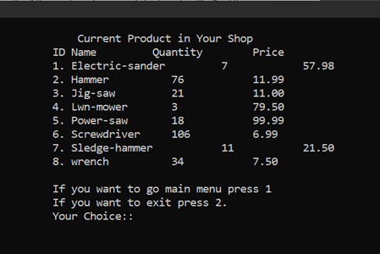

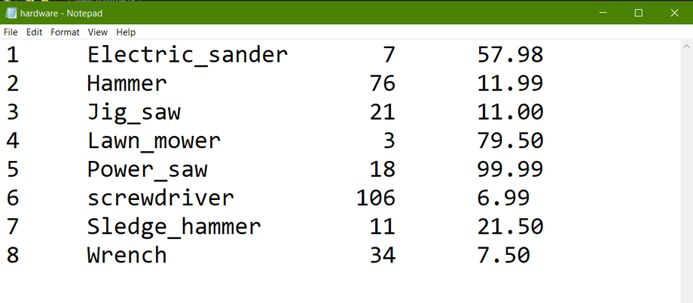

**Answer to the Question Number: 10**

#include <stdio.h>

int main() {

FILE *fp = fopen("data-size.dat", "w");

fprintf(fp, "Data type Size\n");

fprintf(fp, "char %d\n", sizeof(char));

fprintf(fp, "unsigned char %d\n", sizeof(unsigned char));

fprintf(fp, "short int %d\n", sizeof(short int));

fprintf(fp, "unsigned short int %d\n", sizeof(unsigned short int));

fprintf(fp, "int %d\n", sizeof(int));

fprintf(fp, "unsigned int %d\n", sizeof(unsigned int));

fprintf(fp, "long int %d\n", sizeof(long int));

fprintf(fp, "unsigned long int %d\n", sizeof(unsigned long int));

fprintf(fp, "float %d\n", sizeof(float));

fprintf(fp, "double %d\n", sizeof(double));

fprintf(fp, "long double %d\n", sizeof(long double));

fclose(fp);

return 0;

};

